New Member: Oleksii Fedorenko

### Member Interviewed: Lucien Lee

Major of Brother: Computer Science

Year: 2023

Date: 03/13/2021

Phone: Have

Once you’ve gotten the above information, you may then ask the brother a few questions. **Your first three questions must be serious.** I have provided a list below of questions. You can use those or make up your own with a similar feel. The final three questions are up to you to make. You must have 6 questions, however the more you ask the better!

1. Suppose the chapter was just given a $50,000 grant and you're in charge of it. What would you do with it?
   1. Grand upscale piano room. Storage room renovation. High end office.
2. What drives you to succeed?
   1. Money – personal finance from childhood.
3. What are you involved in on campus?
   1. Orientation leader. Sports.

Additional:

1. Where do you see your career in 5 years?
   1. Work on company of dads best friend. To improve company finance and development.
2. If you did not have to work for a living, what would you do?
   1. Buy cars, buy house. Just chill. Start trust funds for friends. Get the bag share the wealth.
3. Did you ever want to create a startup?
   1. Tried to do literally this summer.
4. Do you have an internship and how did you get it?
   1. Web dev with dad’s friend.
5. How do you manage your time?
   1. Poorly. But has a TODO list that he does every day.

Fun:

1. What has been your coolest moment as a ZBT?
   1. Formal.
2. If you had the option to never have to sleep again, or never have to eat again, which would you choose? Why?
   1. Sleep.
3. What is the coolest/ most stupid think you have done in your life?
   1. Went to Canada with roommates. Had allergic reaction to alcohol and punched hole in Airbnb.

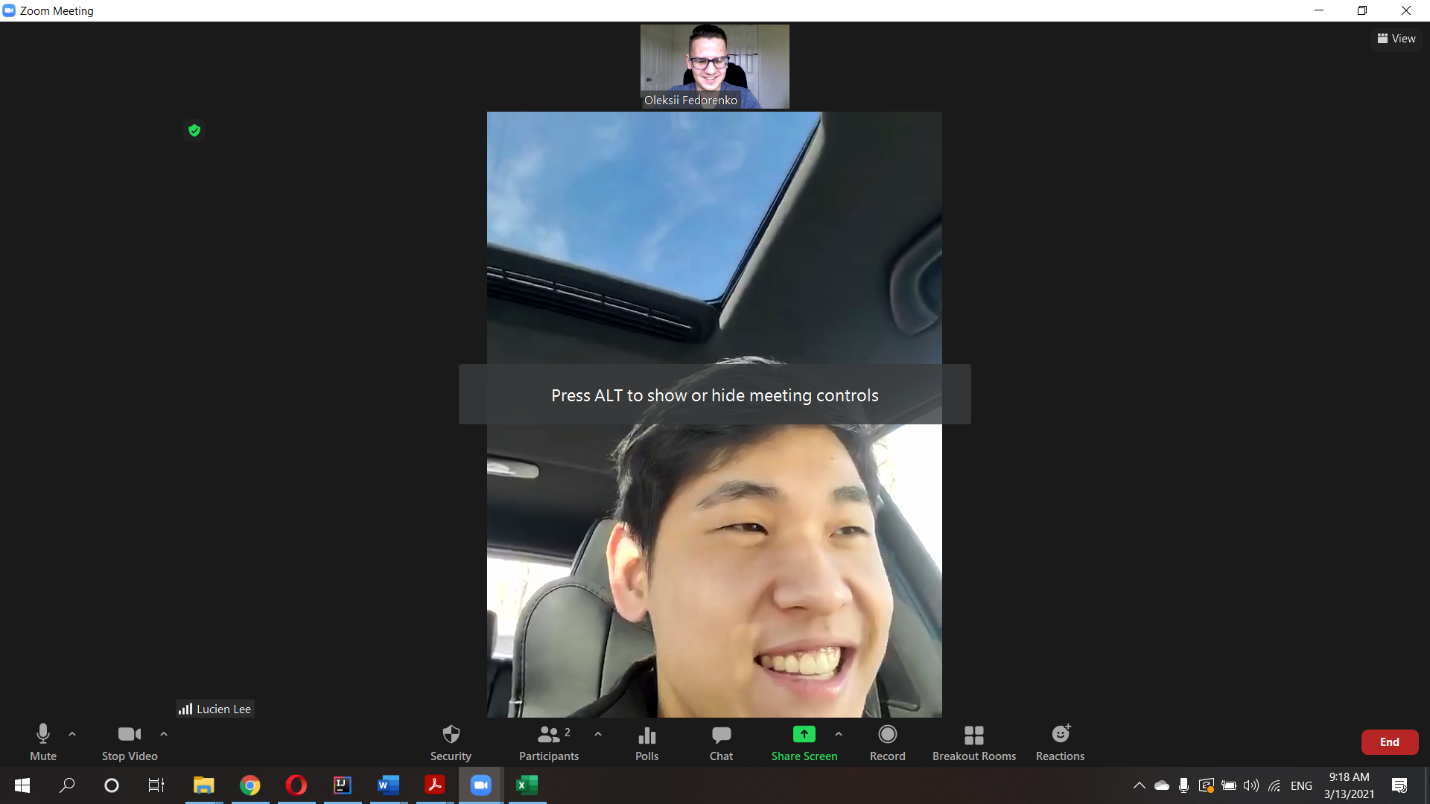

New Member: Oleksii Fedorenko

### Member Interviewed: Franklin Dong

Major of Brother: BA bio, MA psychology, Premed

Year: 2023

Date: 03/13/2021

Phone: Have

Once you’ve gotten the above information, you may then ask the brother a few questions. **Your first three questions must be serious.** I have provided a list below of questions. You can use those or make up your own with a similar feel. The final three questions are up to you to make. You must have 6 questions, however the more you ask the better!

1. Suppose the chapter was just given a $50,000 grant and you're in charge of it. What would you do with it?
   1. Save. Find what chapter wants.
2. What drives you to succeed?
   1. Competitive.
3. What are you involved in on campus?
   1. Exec in 3 clubs. 3 other clubs. Pre-med club. She is the third. Asian American alliance. Cancer action network. Some other.

Additional:

1. Where do you see your career in 5 years?
   1. Residency – Fellowship – Doctor.
   2. Some research in Cancer.
2. If you did not have to work for a living, what would you do?
   1. Travel, action, etc. Explore nature. Extreme sports.
3. Did you ever want to create a startup?
   1. Thought about it, but not his field.
4. Do you have an internship and how did you get it?
   1. While in high school he had internship in Cleveland clinic for 2 years.
5. How do you manage your time?
   1. Some calendar, but keeps a lot in the head.

Fun:

1. What has been your coolest moment as a ZBT?
   1. Raiders.
2. If you had the option to never have to sleep again, or never have to eat again, which would you choose? Why?
   1. Sleep.
3. What is the coolest or most stupid think you have done in your life?
   1. Climbing Mountains in China.

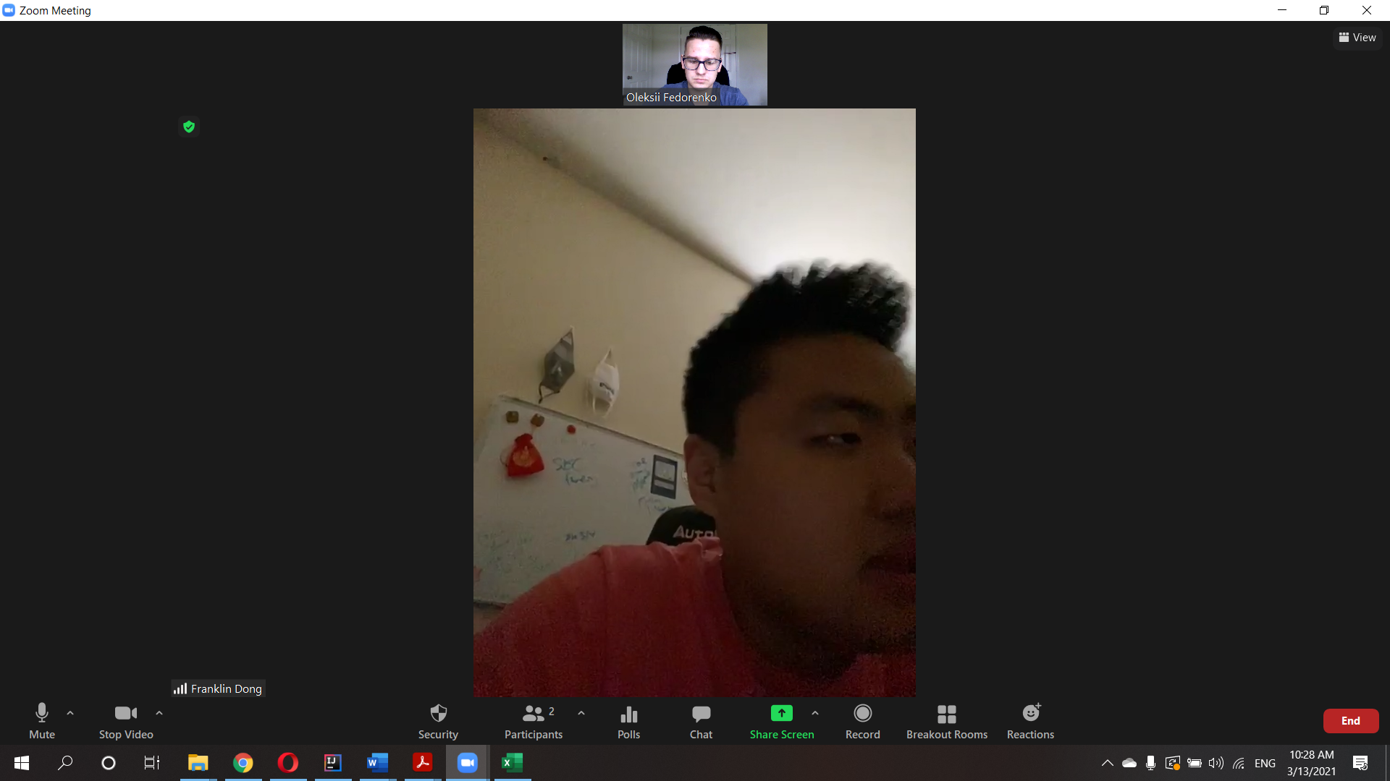

New Member: Oleksii Fedorenko

### Member Interviewed: Raphael Aleman

Major of Brother: Economics/ pol sci.

Year: 2022

Date: 03/13/2021

Phone: 7862536646

Once you’ve gotten the above information, you may then ask the brother a few questions. **Your first three questions must be serious.** I have provided a list below of questions. You can use those or make up your own with a similar feel. The final three questions are up to you to make. You must have 6 questions, however the more you ask the better!

1. Suppose the chapter was just given a $50,000 grant and you're in charge of it. What would you do with it?
   1. Awesome philanthropy event.
   2. Donate or some other stuff.
2. What drives you to succeed?
   1. Competition with yourself. Trying to reach perfect yourself. Having vision and trying to achieve it. Never settled.
3. What are you involved in on campus?

Additional:

1. Where do you see your career in 5 years?
   1. Economic development – city development and analysis. How he as an economist can impact that.
2. If you did not have to work for a living, what would you do?
   1. Working towards economic development of Latin America / Ecuador.
3. Did you ever want to create a startup?
   1. Yes
4. If you had the option to never have to sleep again, or never have to eat again, which would you choose? Why?

New Member: Oleksii Fedorenko

### Member Interviewed: Dashiell Lee

Major of Brother: Nursing

Year: 2023

Date: 03/13/2021

Phone: 6504645628

Once you’ve gotten the above information, you may then ask the brother a few questions. **Your first three questions must be serious.** I have provided a list below of questions. You can use those or make up your own with a similar feel. The final three questions are up to you to make. You must have 6 questions, however the more you ask the better!

1. Suppose the chapter was just given a $50,000 grant and you're in charge of it. What would you do with it?
   1. Gym.
2. What drives you to succeed?
   1. Moral and values from parents and of course money.
3. What are you involved in on campus?
   1. Some clubs. Also wants to start MMA club.

Additional:

1. Where do you see your career in 5 years?
   1. Graduate in 2 years, move to Californian and work in hospital with parents.
2. If you did not have to work for a living, what would you do?
   1. Farm, hang out, chill.
3. Did you ever want to create a startup?
   1. Yes. Working on a patent with dad.
4. How do you manage your time?
   1. Basically routine determined by classes.

Fun:

1. What has been your coolest moment as a ZBT?
   1. Retreat.
2. If you had the option to never have to sleep again, or never have to eat again, which would you choose? Why?
   1. Eating. Money – spend much less time on this. Sleeping awesome.
3. What is the coolest/ most stupid think you have done in your life?
   1. Traveled with youth symphony. Plays French horn.

New Member: Oleksii Fedorenko

### Member Interviewed: Ben Harrison

Major of Brother: Mechanical/ Aerospace

Year: 2021

Date: 03/13/2021

Phone: Have

Questions:

1. Suppose the chapter was just given a $50,000 grant and you're in charge of it. What would you do with it?
   1. Scholarship Fund. Some cool events/service event.
2. What drives you to succeed?
   1. Enjoy seeing results and have meaningful work.
3. What are you involved in on campus?
   1. Steel bridge team.

Additional:

1. Where do you see your career in 5 years?
   1. Manager role in a job I enjoy.
2. If you did not have to work for a living, what would you do?
   1. Get back to community. Education/ After school for kids.
3. Did you ever want to create a startup?
   1. Never had an idea, but quite intrigues.
4. Do you have an internship and how did you get it?
   1. Manufacturing for aerospace industry co-op.
5. How do you manage your time?
   1. Got better at college. Especially off-campus – chores.

Fun:

1. What has been your coolest moment as a ZBT?
   1. Haunted house fundraiser. Working together towards common goal.
2. If you had the option to never have to sleep again, or never have to eat again, which would you choose? Why?
   1. Eat. Don’t get hungry when in the middle of something.
3. What is the coolest/ most stupid think you have done in your life?
   1. Counselor in the summer camp. No worries.

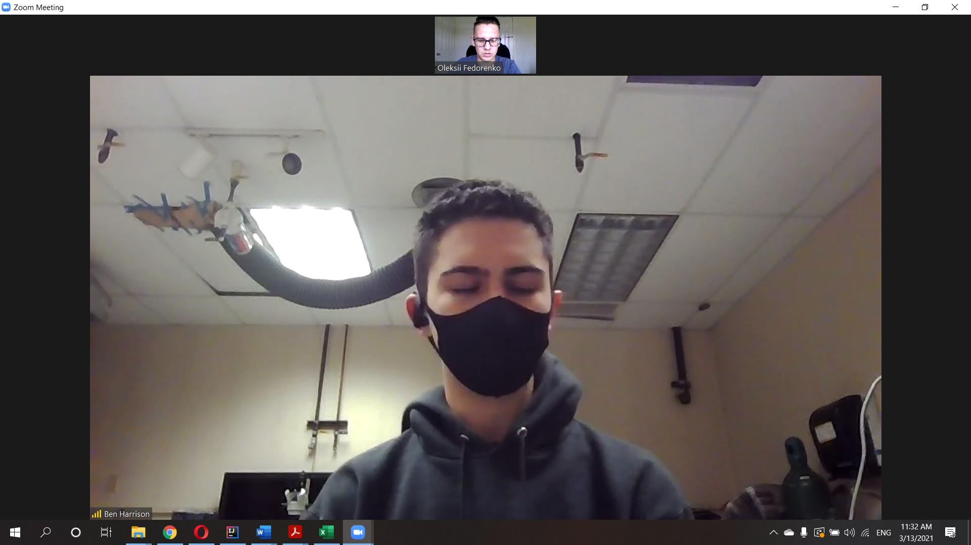

New Member: Oleksii Fedorenko

### Member Interviewed: Jake Rose

Major of Brother: Chemical Engineering + Minor in Business Management

Year: 2021

Date: 03/13/2021

Phone: 4126130078

Once you’ve gotten the above information, you may then ask the brother a few questions. **Your first three questions must be serious.** I have provided a list below of questions. You can use those or make up your own with a similar feel. The final three questions are up to you to make. You must have 6 questions, however the more you ask the better!

1. Suppose the chapter was just given a $50,000 grant and you're in charge of it. What would you do with it?
   1. Hot tub.
2. What drives you to succeed?
   1. Curiosity. Duty and desire to have a good future. Competitive especially in sports.
3. What are you involved in on campus?
   1. Not really. Was in swim team, but active in ZBT.

Additional:

1. Where do you see your career in 5 years?
   1. Job he likes. Enjoying time. Some powerlifting.
2. If you did not have to work for a living, what would you do?
   1. Travel maybe New Zealand.
3. Did you ever want to create a startup?
   1. Thought about it. Things didn’t line up yet. Mix any flavors for drinks that you want in restaurants.
4. Do you have an internship and how did you get it?
   1. Applying for different jobs.
5. How do you manage your time?
   1. Not a very organized person. Just keep in the head, some google calendar and notes.

Fun:

1. What has been your coolest moment as a ZBT?
   1. Retreat. Cabin in the woods.
2. If you had the option to never have to sleep again, or never have to eat again, which would you choose? Why?
   1. Sleep.
3. What is the coolest/ most stupid think you have done in your life?
   1. Fell off the dorm roof.

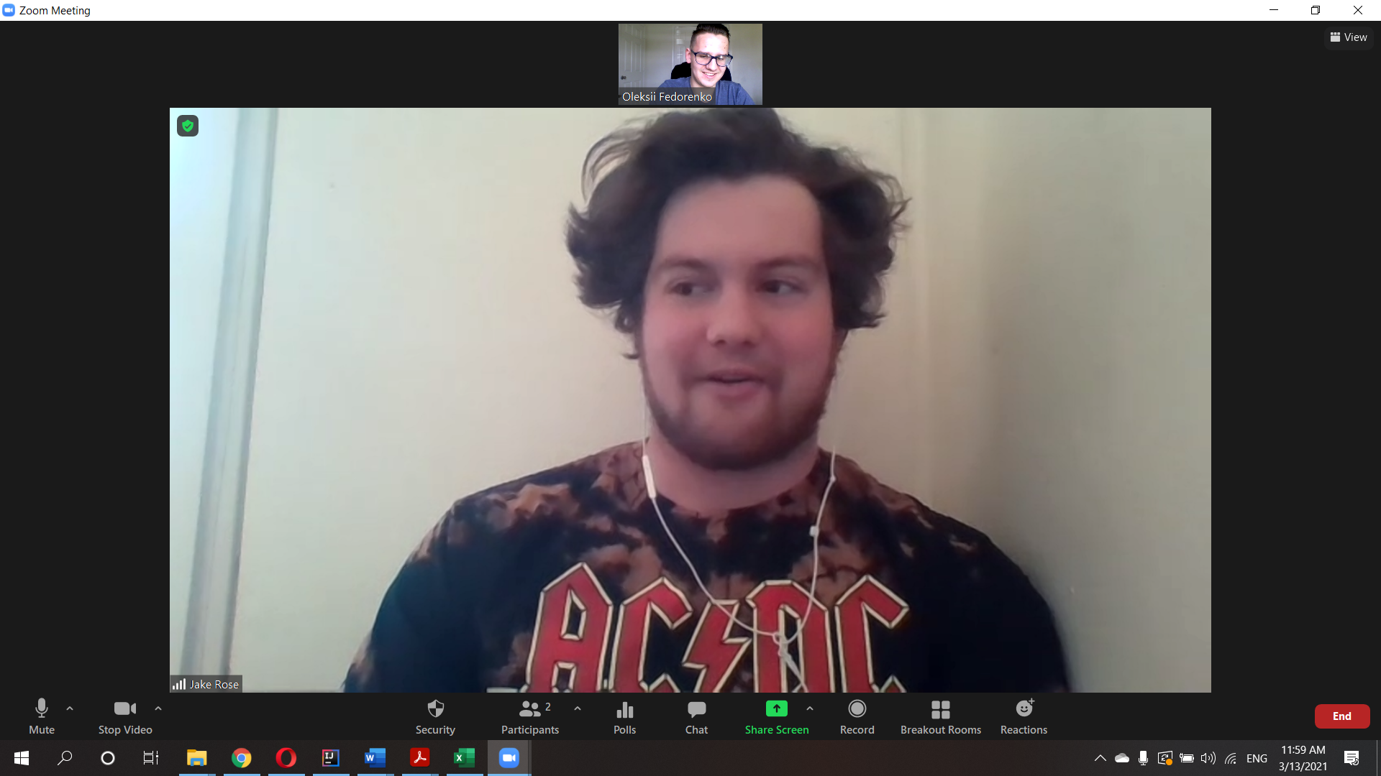

New Member: Oleksii Fedorenko

### Member Interviewed: Jack Bilotti

Major of Brother: Computer Science

Year: 2021

Date: 03/13/2021

Phone: 914-559-8299

Once you’ve gotten the above information, you may then ask the brother a few questions. **Your first three questions must be serious.** I have provided a list below of questions. You can use those or make up your own with a similar feel. The final three questions are up to you to make. You must have 6 questions, however the more you ask the better!

1. Suppose the chapter was just given a $50,000 grant and you're in charge of it. What would you do with it?
   1. Huge trip – bonding experience.
2. What drives you to succeed?
   1. Try to work as hard as dad, and he tried to work as hard as his dad. Support a family.
3. What are you involved in on campus?
   1. Hackathon.

Additional:

1. Where do you see your career in 5 years?
   1. Work in the office in comp sci. Security in computer science.
2. If you did not have to work for a living, what would you do?
   1. Being a student.
3. Did you ever want to create a startup?
   1. A lot of project, but nothing investable.
4. Do you have an internship and how did you get it?
   1. Got before college and returned there all the summers.
5. How do you manage your time?
   1. Treat every day as 9 to 5 job for study.

Fun:

1. What has been your coolest moment as a ZBT?
   1. Rope pull days with big sporty guys.
2. If you had the option to never have to sleep again, or never have to eat again, which would you choose? Why?
   1. Sleep.
3. What is the coolest/ most stupid think you have done in your life?

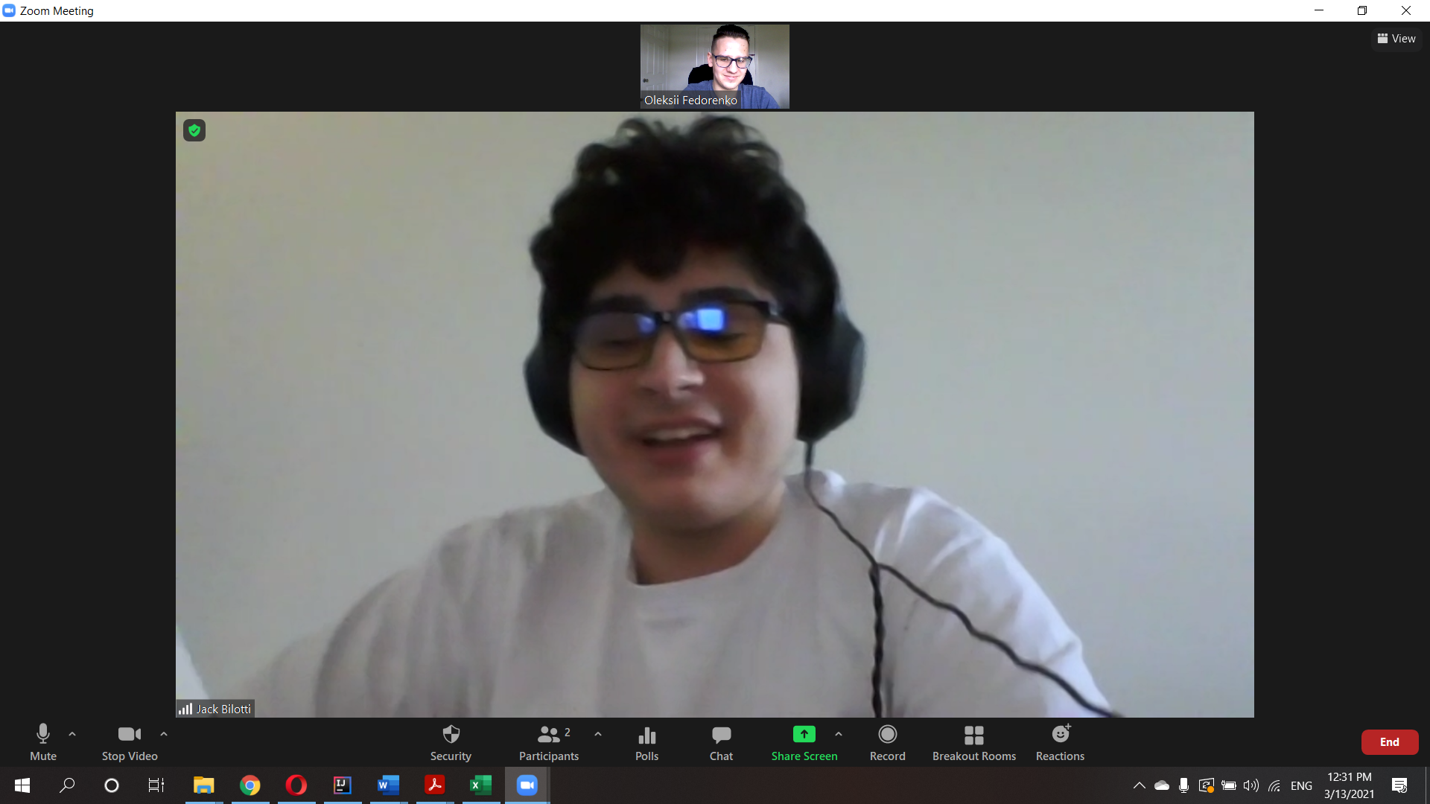

New Member: Oleksii Fedorenko

### Member Interviewed: Takoda Donhof

Major of Brother: Data Science

Year: 2022

Date: 03/13/2021

Phone: Have it

Once you’ve gotten the above information, you may then ask the brother a few questions. **Your first three questions must be serious.** I have provided a list below of questions. You can use those or make up your own with a similar feel. The final three questions are up to you to make. You must have 6 questions, however the more you ask the better!

1. Suppose the chapter was just given a $50,000 grant and you're in charge of it. What would you do with it?
   1. Retreat, basketball. Gym.
2. What drives you to succeed?
   1. Financial Freedom.
3. What are you involved in on campus?
   1. Hockey. Captain of CWRU hockey. Research on COVID data. Peter Zimmerman and ____.
   2. Bio cell fibers research.

Additional:

1. Where do you see your career in 5 years?
   1. Pay off loans – get masters – maybe in physics or aerospace.
2. If you did not have to work for a living, what would you do?
   1. Move to Montana, ranch, ski non-stop.
3. Did you ever want to create a startup?
   1. Wants to create a startup – robinhood, but for VC. Allow people to invest into startups.
4. Do you have an internship and how did you get it?
   1. Doing research.
5. How do you manage your time?
   1. Day by day. Week by week. TODO lists. Uses app called Notion.

Fun:

1. What has been your coolest moment as a ZBT?
   1. Rope pull days with big sporty guys. Party hard afterward.
2. If you had the option to never have to sleep again, or never have to eat again, which would you choose? Why?
   1. Sleep.
3. What is the coolest/ most stupid think you have done in your life?
   1. Went to Sweden to play hockey.

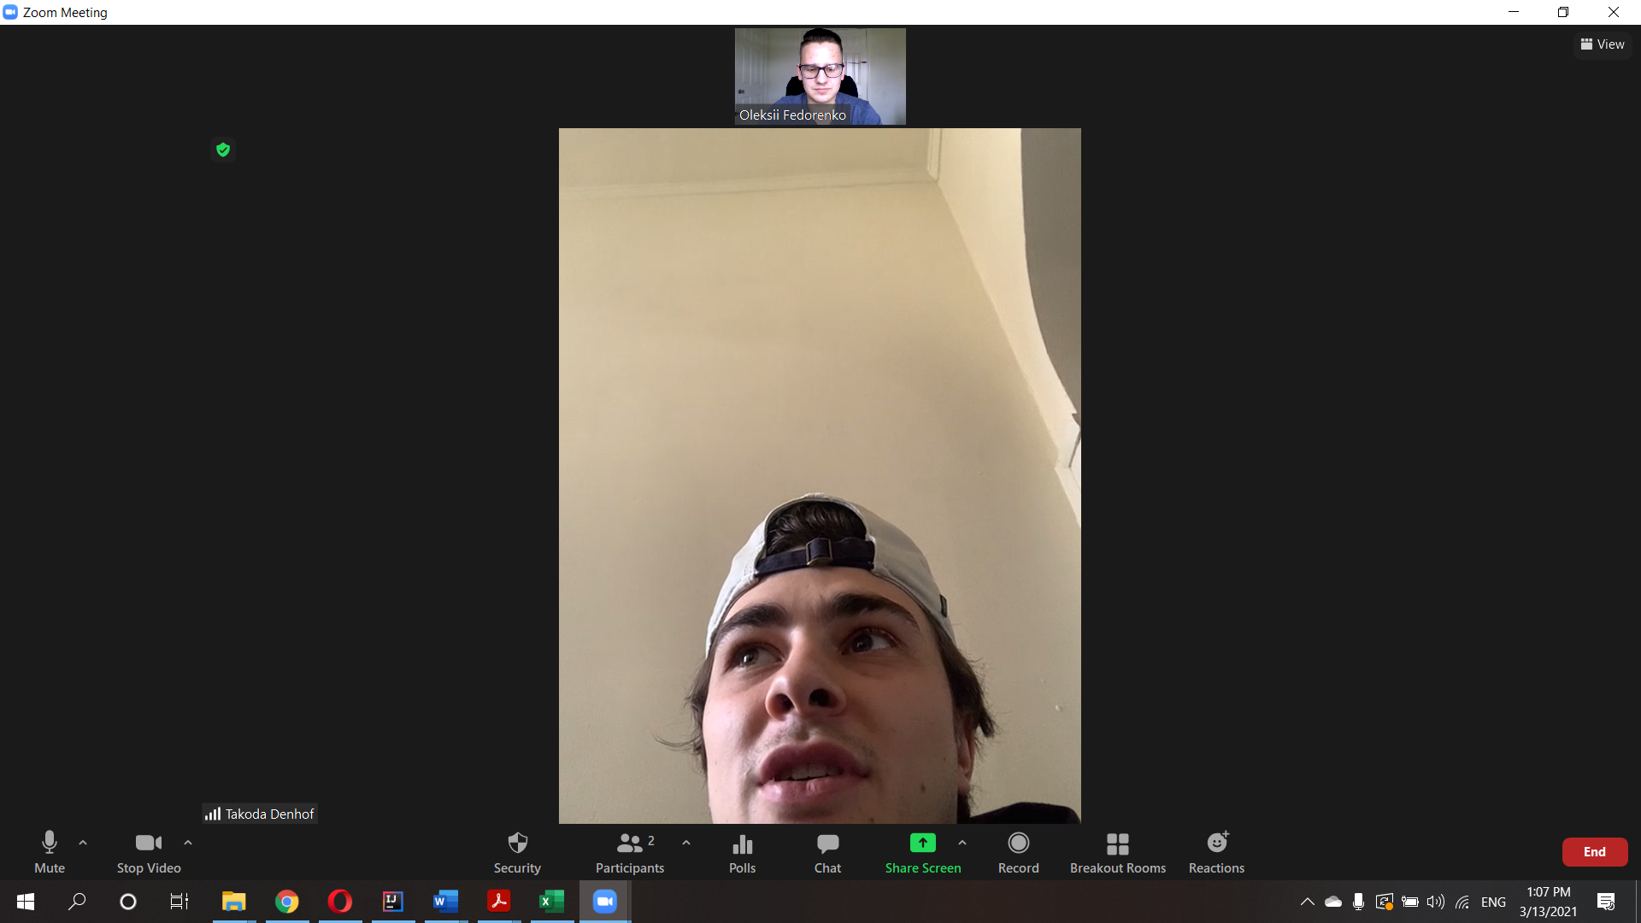

New Member: Oleksii Fedorenko

### Member Interviewed: Casey Goodman

Major of Brother: Chemical Engineer

Year: 2021

Date: 03/13/2021

Phone: 636-346-8693

Main:

1. Suppose the chapter was just given a $50,000 grant and you're in charge of it. What would you do with it?
   1. Philanthropy. Renovation.
2. What drives you to succeed?
   1. Some self-driven. Some vision.
3. What are you involved in on campus?
   1. CHEM 111 TA. Really involved in fraternity.

Additional:

1. Where do you see your career in 5 years?
   1. Process engineer to manager. Change a couple of companies
2. If you did not have to work for a living, what would you do?
   1. Move to Europe – nice warm area. Play tennis, nature.
3. Did you ever want to create a startup?
   1. NO. Maybe in the future. Brewing – retirement.
4. Do you have an internship and how did you get it?
   1. Doing co-op right now.
5. How do you manage your time?
   1. Notes. TODO list. Homework TODO list in every class. Busy week schedule.

Fun:

1. What has been your coolest moment as a ZBT?
   1. Freshman Retreat.
2. If you had the option to never have to sleep again, or never have to eat again, which would you choose? Why?
   1. Sleep.
3. What is the coolest/ most stupid think you have done in your life?
   1. Sophomore and ZBT smoked weed in Toronto in the car. Almost got caught by cops, but didn’t because everything smoked as weed.

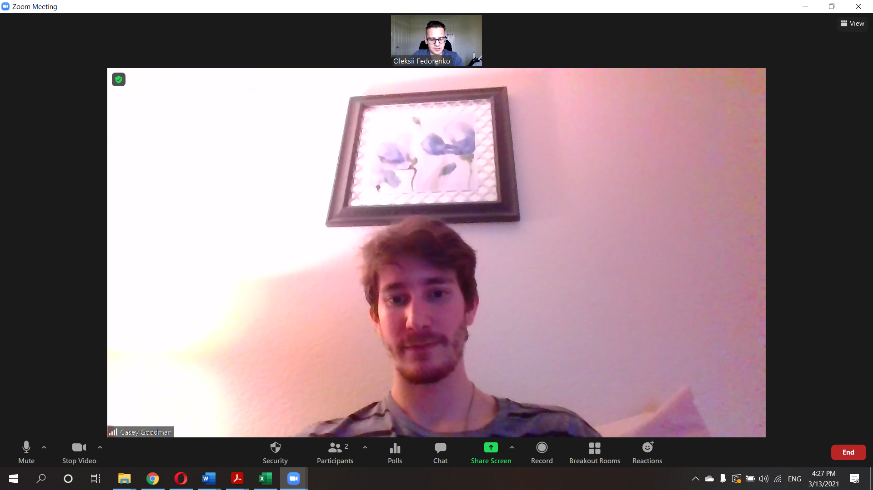

New Member: Oleksii Fedorenko

### Member Interviewed: Alex Estright

Major of Brother: Neuroscience

Year: 2023

Date: 03/14/2021

Phone: Have it

Once you’ve gotten the above information, you may then ask the brother a few questions. **Your first three questions must be serious.** I have provided a list below of questions. You can use those or make up your own with a similar feel. The final three questions are up to you to make. You must have 6 questions, however the more you ask the better!

1. Suppose the chapter was just given a $50,000 grant and you're in charge of it. What would you do with it?
   1. Set aside 15000 to savings.
   2. Massive philanthropy event.
2. What drives you to succeed?
   1. Make parents proud.
3. What are you involved in on campus?
   1. IFC sociate justice position.
   2. AMSA
   3. Some type of scholar program.

Additional:

1. Where do you see your career in 5 years?
   1. End of residency.
2. If you did not have to work for a living, what would you do?
   1. Have some massive parties. Donate some.
3. Did you ever want to create a startup?
   1. Never thought about it.
4. How do you manage your time?
   1. Paper planner. Some calendar.

Fun:

1. What has been your coolest moment as a ZBT?
   1. Last fall philanthropy. Haunted house.
2. If you had the option to never have to sleep again, or never have to eat again, which would you choose? Why?
   1. Sleep.
3. What is the coolest/ most stupid think you have done in your life?
   1. Coming home completely high.

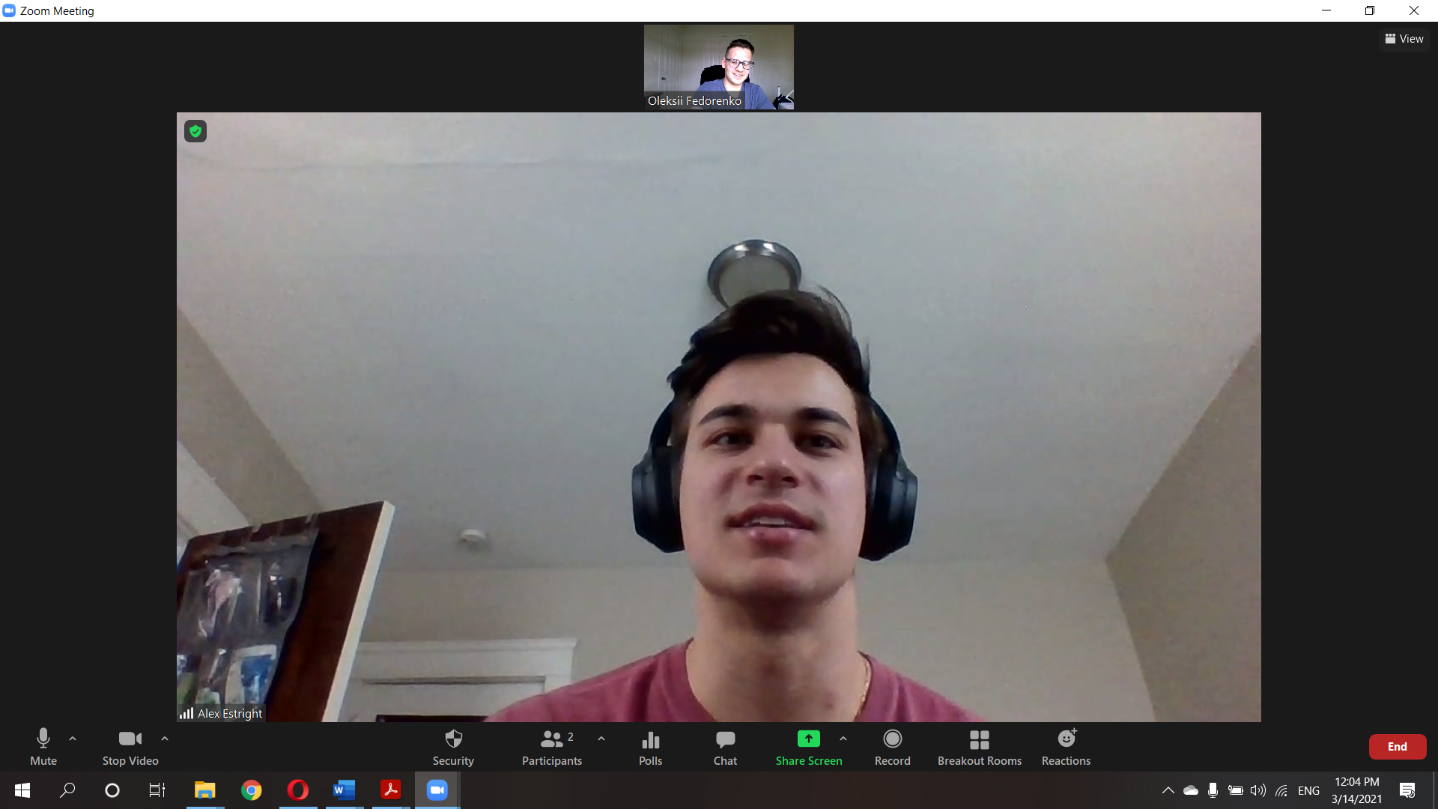

New Member: Oleksii Fedorenko

### Member Interviewed: Jordan Perrot

Major of Brother: Economics, Premed

Year: 2023

Date: 03/14/2021

Phone: 847-975-1706

Once you’ve gotten the above information, you may then ask the brother a few questions. **Your first three questions must be serious.** I have provided a list below of questions. You can use those or make up your own with a similar feel. The final three questions are up to you to make. You must have 6 questions, however the more you ask the better!

1. Suppose the chapter was just given a $50,000 grant and you're in charge of it. What would you do with it?
   1. Philanthropy event. Some parties. Something for the whole case community.
2. What drives you to succeed?
   1. Goal to become a doctor. Wanting a better future for himself.
3. What are you involved in on campus?
   1. Not much. Water polo. Varsity swimmer.

Additional:

1. Where do you see your career in 5 years?
   1. Residency – doctor. Wants to enjoy what he is doing.
2. If you did not have to work for a living, what would you do?
   1. Would still be a doctor. Fulfilling job. Also travel.
3. Did you ever want to create a startup?
   1. Yes. Roni is very entrepreneurial. Electric skateboard company. Thinkbox funding for a prototype.
   2. Philanthropic taco.
4. How do you manage your time?
   1. Work hard – play hard. Have some priority list.

Fun:

1. What has been your coolest moment as a ZBT?
   1. Go to hockey games and root for friends. Some parties.
2. If you had the option to never have to sleep again, or never have to eat again, which would you choose? Why?
   1. Eat – so hard to find a time to eat and cook.
3. What is the coolest/ most stupid think you have done in your life?
   1. Breaking elbow while skateboarding. Culmination of stupid thing.
   2. Drunk at one of the parties threw up on the parking lot.

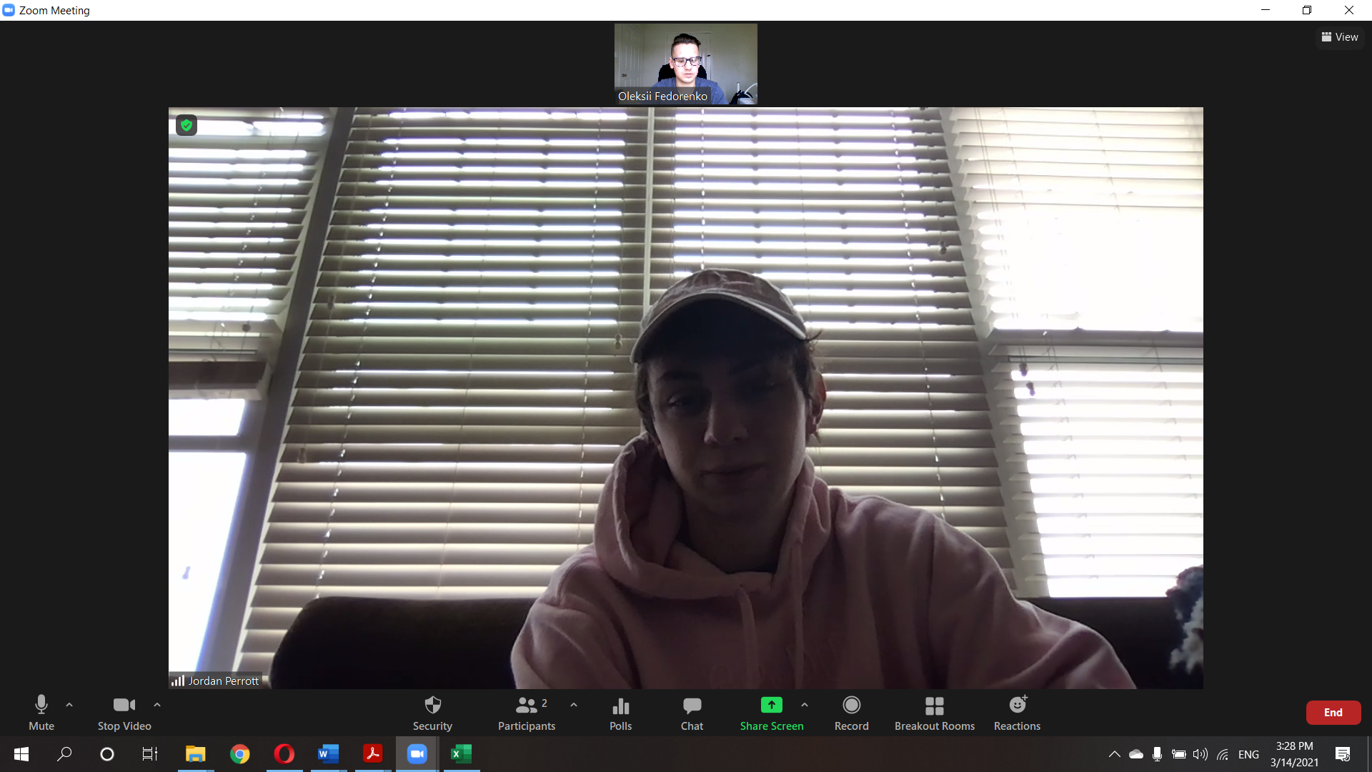

New Member: Oleksii Fedorenko

### Member Interviewed: Noah Vardy

Major of Brother: Physics

Year: 2022

Date: 03/14/2021

Phone:

Questions:

1. Suppose the chapter was just given a $50,000 grant and you're in charge of it. What would you do with it?
   1. Save half of it. 3 cool parties. Renovation.
2. What drives you to succeed?
   1. He likes to do stuff that he is interested in. Fulfilling.
3. What are you involved in on campus?
   1. Research in Physics. Ski club.

Additional:

1. Where do you see your career in 5 years?
   1. Graduate school – Doing some research. SpaceX.
2. If you did not have to work for a living, what would you do?
   1. Make videos about skiing.
3. Did you ever want to create a startup?
   1. Not really. Doing science.
4. How do you manage your time?
   1. Intermittently. Get done work earlier.

Fun:

1. What has been your coolest moment as a ZBT?
   1. Sidewalk slammer.
   2. Went skiing with brothers.
2. If you had the option to never have to sleep again, or never have to eat again, which would you choose? Why?
   1. Sleep.
3. What is the coolest/ most stupid think you have done in your life?
   1. Doing some skiing tricks.
   2. Race for sidewalk slammer.

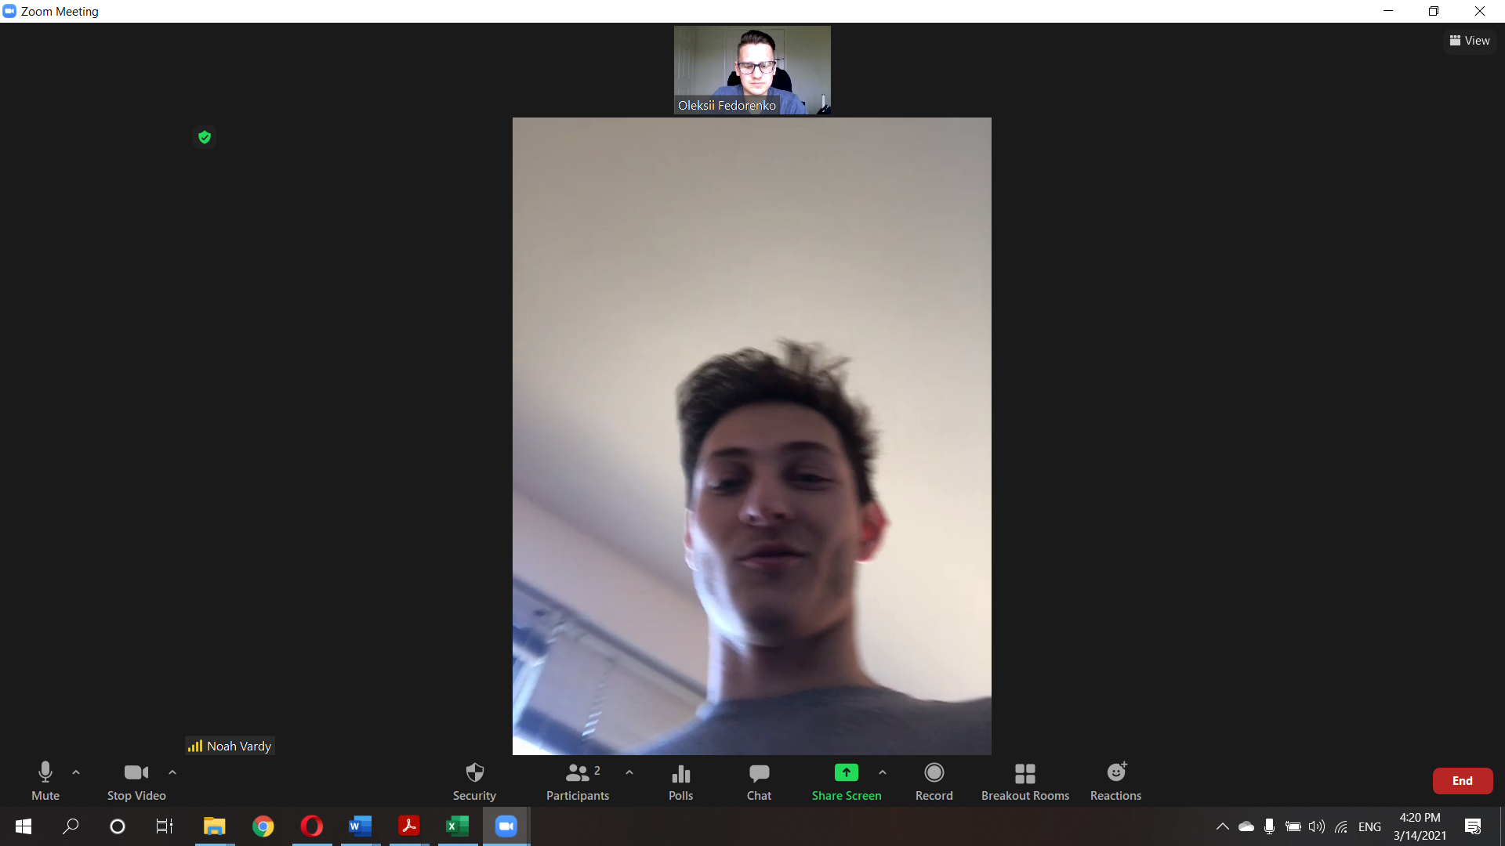

New Member: Oleksii Fedorenko

### Member Interviewed: Raul Mariani

Major of Brother: Aerospace Engineering

Year: 2023

Date: 03/14/2021

Phone: 7874285715

Questions:

1. Suppose the chapter was just given a $50,000 grant and you're in charge of it. What would you do with it?
   1. Renovate. Some philanthropy.
2. What drives you to succeed?
   1. Goals, friends support.
3. Where do you see your career in 5 years?
   1. Space company. SpaceX.
4. If you did not have to work for a living, what would you do?
   1. Invest money. Family, chilling, streaming on twitter.
5. What are you involved in on campus?
   1. Founder of set screw. Big games club.
6. Did you ever want to create a startup?
   1. No.
7. Do you have an internship and how did you get it?
   1. Next year.
8. How do you manage your time?
   1. Pretty randomized.
9. What has been your coolest moment as a ZBT?
   1. Initiation. Retreat.
10. What is the coolest/ most stupid think you have done in your life?
    1. Worked in an observatory.
    2. Skiing
11. If you had the option to never have to sleep again, or never have to eat again, which would you choose? Why?
    1. Sleep.

New Member: Oleksii Fedorenko

### Member Interviewed: Yoochan Lee

Major of Brother: Pre-med, Nutritional Biochemistry

Year: 2023

Date: 03/14/2021

Phone: 8478571543

Questions:

1. Suppose the chapter was just given a $50,000 grant and you're in charge of it. What would you do with it?
   1. Basketball court.
2. What drives you to succeed?
   1. Achieve goals. Competitive. Don’t like mediocrity.
3. Where do you see your career in 5 years?
   1. Med school – doctor.
4. If you did not have to work for a living, what would you do?
   1. Youtube videos. Chilling. Documentaries.
5. What are you involved in on campus?
   1. President Calisthenics club
6. Did you ever want to create a startup?
   1. Yes. When older will try to start a business.
7. How do you manage your time?
   1. Reminders. To-do list.
8. What has been your coolest moment as a ZBT?
   1. Parties, events. Throw bag.
9. What is the coolest/ most stupid think you have done in your life?
   1. Longboarding from the hill and almost getting hit by a car.
10. If you had the option to never have to sleep again, or never have to eat again, which would you choose? Why?
    1. Sleep. Eating the greatest pleasure.

New Member: Oleksii Fedorenko

### Member Interviewed: Abraham Wolpert

Major of Brother: Economics

Year: 2023

Date: 03/14/2021

Phone: 3522262847

Questions:

1. Suppose the chapter was just given a $50,000 grant and you're in charge of it. What would you do with it?
   1. Movie Theater room.
2. What drives you to succeed?
   1. Not let parents down.
3. Where do you see your career in 5 years?
   1. No clue.
4. If you did not have to work for a living, what would you do?
   1. Travel. Chilling.
5. What are you involved in on campus?
   1. Some sports.
6. Did you ever want to create a startup?
   1. Open up a bar.
7. How do you manage your time?
   1. Plan a week every weekend. On paper.
8. What has been your coolest moment as a ZBT?
   1. Initiation. Retreat – going crazy in the woods, but also fulfilling conversations. Some service events.
9. What is the coolest/ most stupid think you have done in your life?
   1. Cabin in NC + 30 beers + super hang over.
10. If you had the option to never have to sleep again, or never have to eat again, which would you choose? Why?
    1. Eat – hate cooking.

New Member: Oleksii Fedorenko

### Member Interviewed: Ryan Tien

Major of Brother: BME

Year: 2023

Date: 03/14/2021

Phone: Have

Questions:

1. Suppose the chapter was just given a $50,000 grant and you're in charge of it. What would you do with it?
   1. Renovate. Pool table. Some Philanthropy. Trip.
2. What drives you to succeed?
   1. Fear of failure.
3. Where do you see your career in 5 years?
   1. Masters – MBA – some work.
4. If you did not have to work for a living, what would you do?
   1. Skiing, chilling.
5. What are you involved in on campus?
   1. Order of Omega.
   2. Sexual Assault committee.
6. Did you ever want to create a startup?
   1. Was thinking about it. Roni is entrepreneurial.
7. Do you have an internship and how did you get it?
   1. 2 internships. ASM international. Data curations, database management.
8. How do you manage your time?
   1. Work hard than play hard.
9. What has been your coolest moment as a ZBT?
   1. Chilling and bonding with brothers.
10. What is the coolest/ most stupid think you have done in your life?
    1. Had sex in a room with friends asleep.
11. If you had the option to never have to sleep again, or never have to eat again, which would you choose? Why?
    1. Sleep.

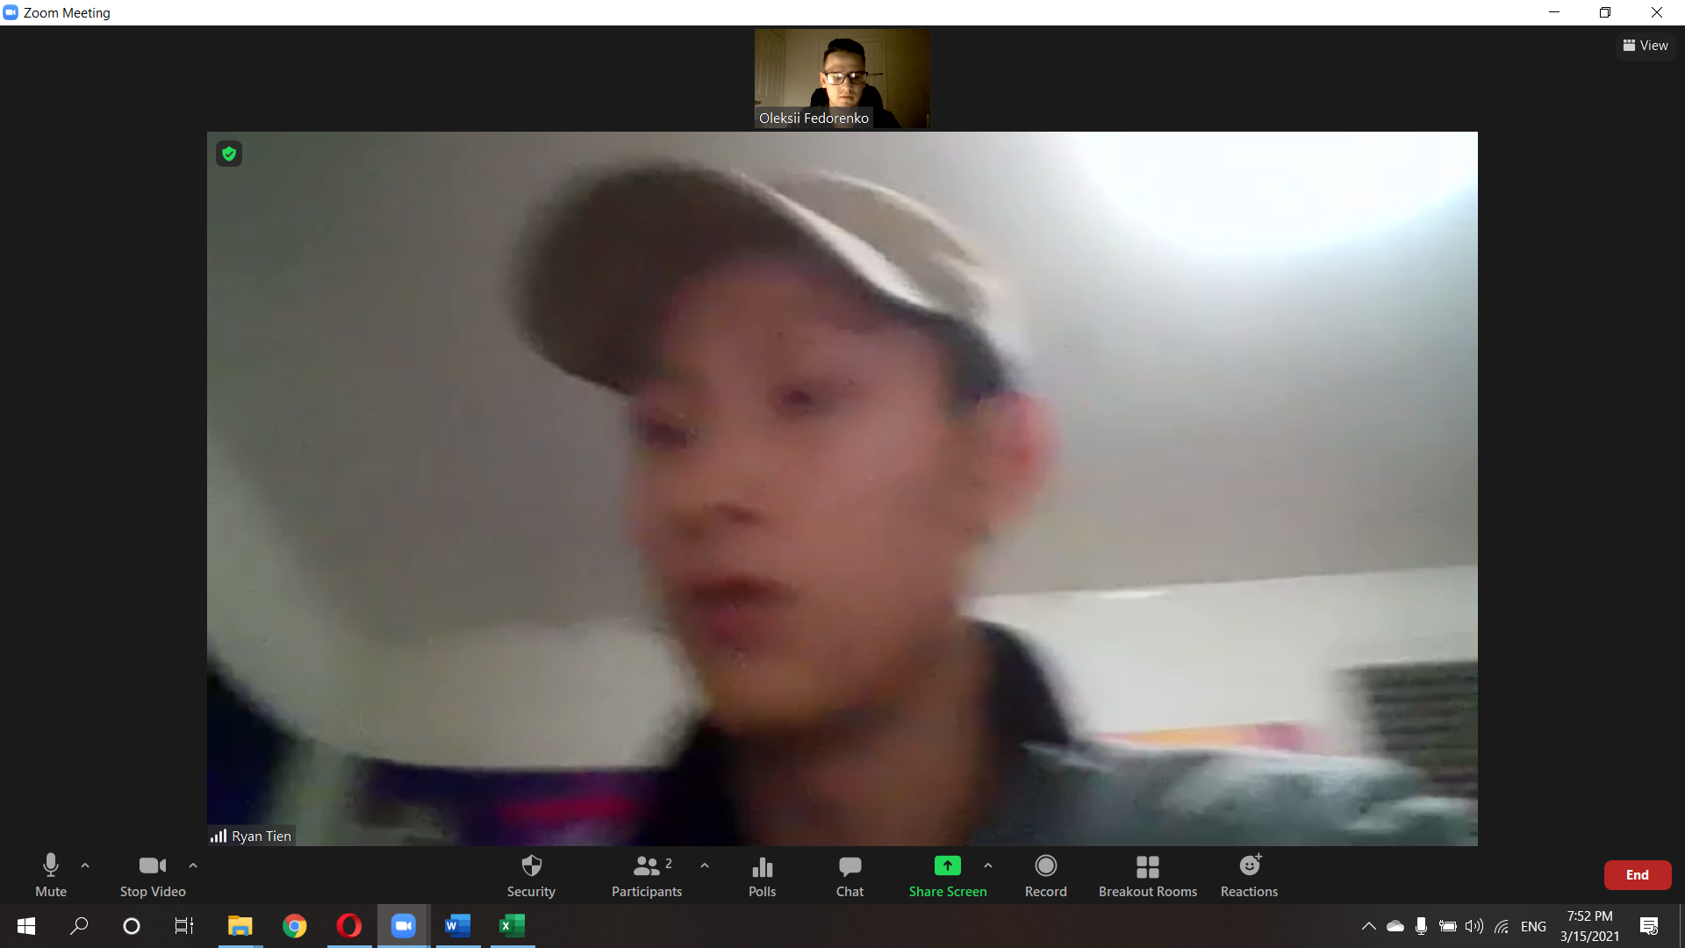

New Member: Oleksii Fedorenko

### Member Interviewed: Carter Flayhart

Major of Brother: Physics, minor Astronomy

Year: 2023

Date: 03/14/2021

Phone: 2404092423

Questions:

1. Suppose the chapter was just given a $50,000 grant and you're in charge of it. What would you do with it?
   1. Buy the house from alumni. Philanthropy events.
   2. Renovation.
2. What drives you to succeed?
   1. High Expectations and Goals.
3. Where do you see your career in 5 years?
   1. Research in Physics.
4. If you did not have to work for a living, what would you do?
   1. Travel. Live in each location for 6-12 month. Do sports betting.
   2. Volunteer at charity.
5. What are you involved in on campus?
   1. Ultimate Frisbee team.
6. Did you ever want to create a startup?
   1. No. Research oriented.
7. Do you have an internship and how did you get it?
   1. Not really. Some dark matter research.
8. How do you manage your time?
   1. Not well. Procrastinate a lot. Everything is spread out through the week, so it turns out well.
   2. Some TODO lists.
9. What has been your coolest moment as a ZBT?
   1. Initiation and recruiting 9 people.
10. What is the coolest/ most stupid think you have done in your life?
    1. Football fan. First ever football game in person.
11. If you had the option to never have to sleep again, or never have to eat again, which would you choose? Why?
    1. Sleep

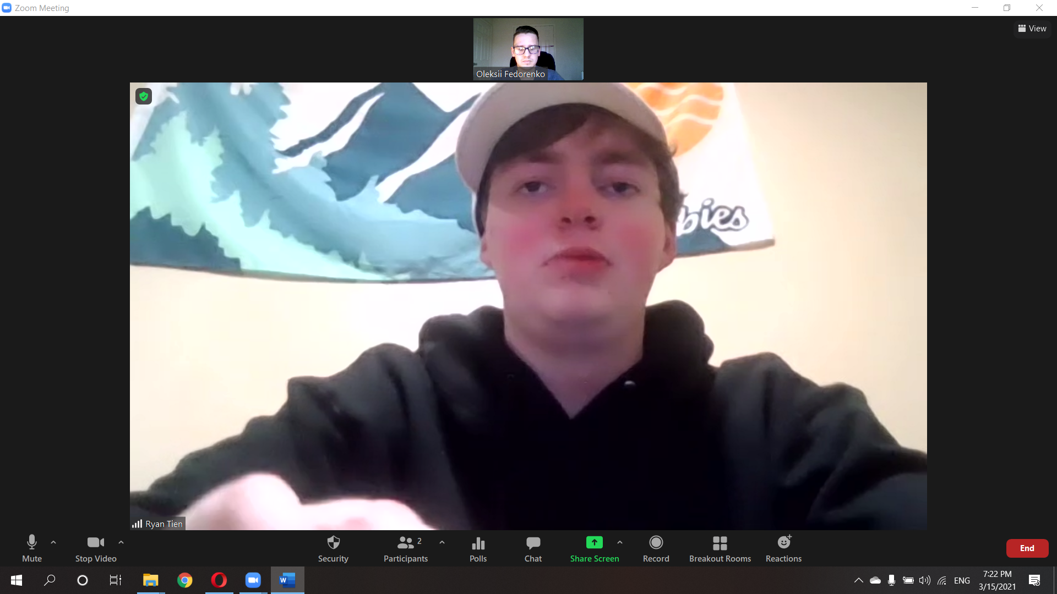

New Member: Oleksii Fedorenko

### Member Interviewed: Matthew Coulanges

Major of Brother: Nutritional Biochemistry, Premed

Year: 2023

Date: 03/14/2021

Phone: 6096356466

Questions:

1. Suppose the chapter was just given a $50,000 grant and you're in charge of it. What would you do with it?
   1. Merit scholarships for members.
2. What drives you to succeed?
   1. Challenges drive him.
3. Where do you see your career in 5 years?
   1. Medical school – residency – doctor
4. If you did not have to work for a living, what would you do?
   1. Learn how to play guitar. Ranch in Texas.
5. What are you involved in on campus?
   1. CCEL
   2. Cleveland Side Center – volunteering. Dramatic reading of books.
6. Did you ever want to create a startup?
   1. Never thought.
7. How do you manage your time?
   1. Big procrastinator. Tries to do stuff right away. Some calendar.
8. What has been your coolest moment as a ZBT?
   1. Brotherhood only events. Traditional events. Bonding.
9. What is the coolest/ most stupid think you have done in your life?
   1. Thought he would be able to levitate based on a TV show. Messed up the whole face.
10. If you had the option to never have to sleep again, or never have to eat again, which would you choose? Why?
    1. Sleep.

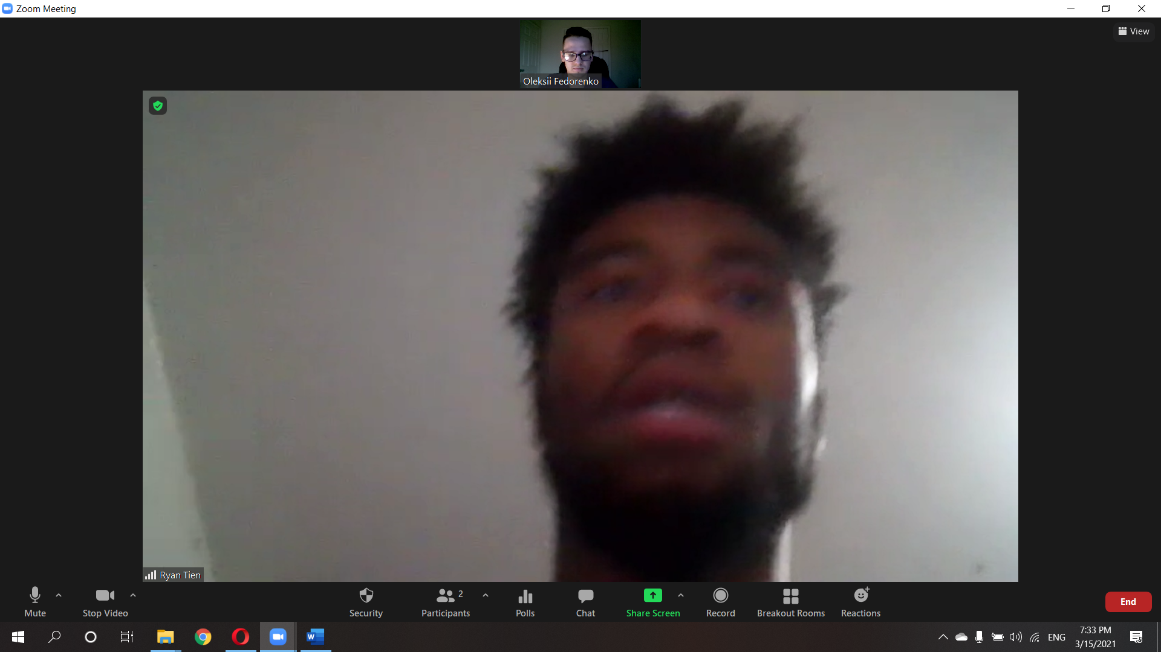

New Member: Oleksii Fedorenko

### Member Interviewed: Dallas McDonald

Major of Brother: Biology, Econ, minor in music’s, Premed

Year: 2022

Date: 03/14/2021

Phone: Have it

Questions:

1. Suppose the chapter was just given a $50,000 grant and you're in charge of it. What would you do with it?
   1. Renovate.
2. What drives you to succeed?
   1. Fear of failure. Self-improvement.
3. Where do you see your career in 5 years?
   1. Medical school – residency – neurosurgeon.
4. If you did not have to work for a living, what would you do?
   1. Still will go into healthcare. Park ranger.
5. What are you involved in on campus?
   1. CSMS.
   2. Jazz band.
   3. Fundraiser for children hospital.
6. Did you ever want to create a startup?
   1. Not really. Go into medical school.
7. Do you have an internship and how did you get it?
   1. Research. Pathology department.
8. How do you manage your time?
   1. Compartmentalize. Apple calendar. TODO list by organizations.
9. What has been your coolest moment as a ZBT?
   1. Spring break when pandemic started.
10. What is the coolest/ most stupid think you have done in your life?
    1. Breaking out into the roof.
    2. Throwing vacuum and it got back.
11. If you had the option to never have to sleep again, or never have to eat again, which would you choose? Why?
    1. Eat.

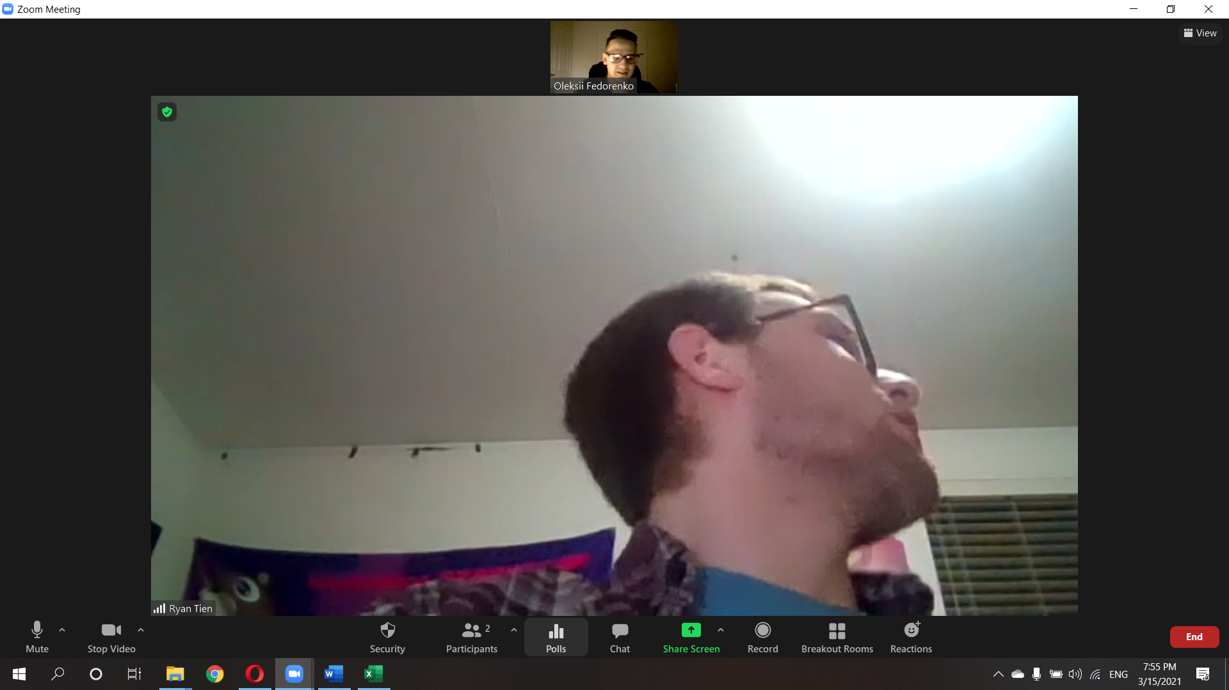

New Member: Oleksii Fedorenko

### Member Interviewed:

Major of Brother:

Year:

Date: 03/14/2021

Phone:

Questions:

1. Suppose the chapter was just given a $50,000 grant and you're in charge of it. What would you do with it?
2. What drives you to succeed?
3. Where do you see your career in 5 years?
4. If you did not have to work for a living, what would you do?
5. What are you involved in on campus?
6. Did you ever want to create a startup?
7. Do you have an internship and how did you get it?
8. How do you manage your time?
9. What has been your coolest moment as a ZBT?
10. What is the coolest/ most stupid think you have done in your life?
11. If you had the option to never have to sleep again, or never have to eat again, which would you choose? Why?